Anaphylaxis – what to do in an emergency
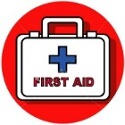
Ask: “Do you suffer from an allergy?”
“Do you have an Adrenaline Auto-Injector? (EpiPen)”

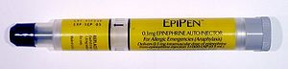
An Adrenaline Injection should be administered as soon as a severe reaction is suspected in the upper outer thigh.

The person should remain as still as possible. If they feel weak or dizzy, lie them down and elevate their legs.

Call 999. Say the person is suffering from anaphylaxis (anna-fill-axis). Give clear and precise directions:
Newnham College, CB3 9DF,
e.g ‘outside the Buttery’ and the Porters’ tel no: 01223 335700).

Inform the Porters’ Lodge immediately so that the Porters can bring an Adrenaline Auto-injector/ direct the ambulance crew

Make a note of the time Adrenaline was given. If no improvement, a second dose can be given after 5 minutes. If the person deteriorates after making the 999 call, make a second call to make sure ambulance has been dispatched. Stay with the person.
An Adrenaline Auto-Injector for use in an emergency is located at the Porters’ Lodge

